Server/Webservice

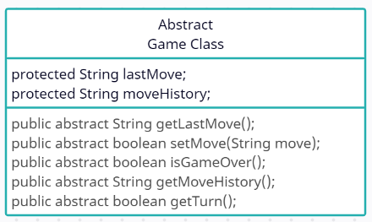Abstract Game class which describes variables and functions that every game should have.

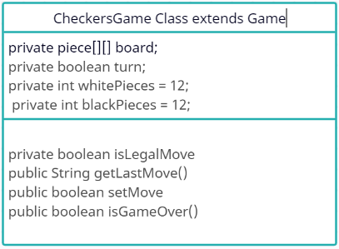Checkers game class which extends game class represents a game of Checkers, contains board and has all functions about the game control and rules.

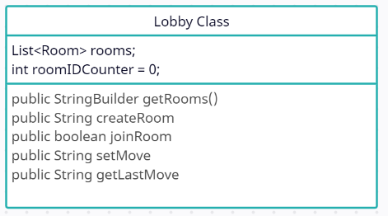

Lobby class manages the game lobby, rooms and has lobby-room related functions.

Handles every webservice request and responds accordingly

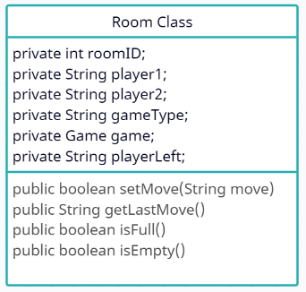

Room class represent a room in a lobby, contains a game, players and functions for room

Client/Android App

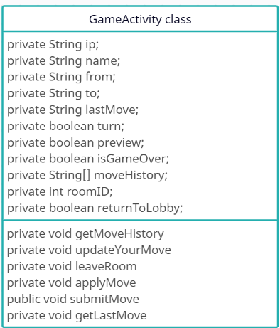

GameActivity class handles the representation of the game, contains variables and factions of game info, server requests

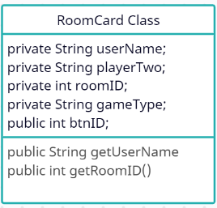

RoomCard Class Saves each room info from the server.

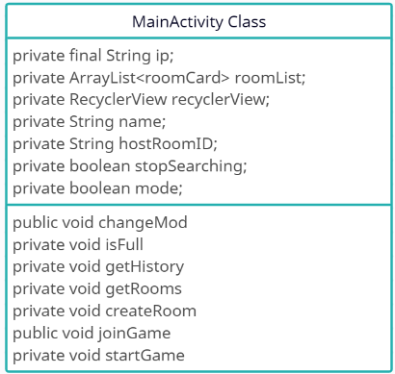

MainActivity class handles the Lobby and game history representation and sends requests to the server accordingly

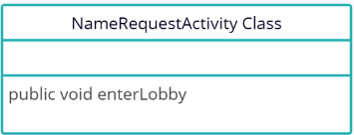

NameRequestActivity Class handles the input from the User and enters the lobby.